1. Admin-User Photo-Edit button-Try to upload a photo and click save button, page gets crashed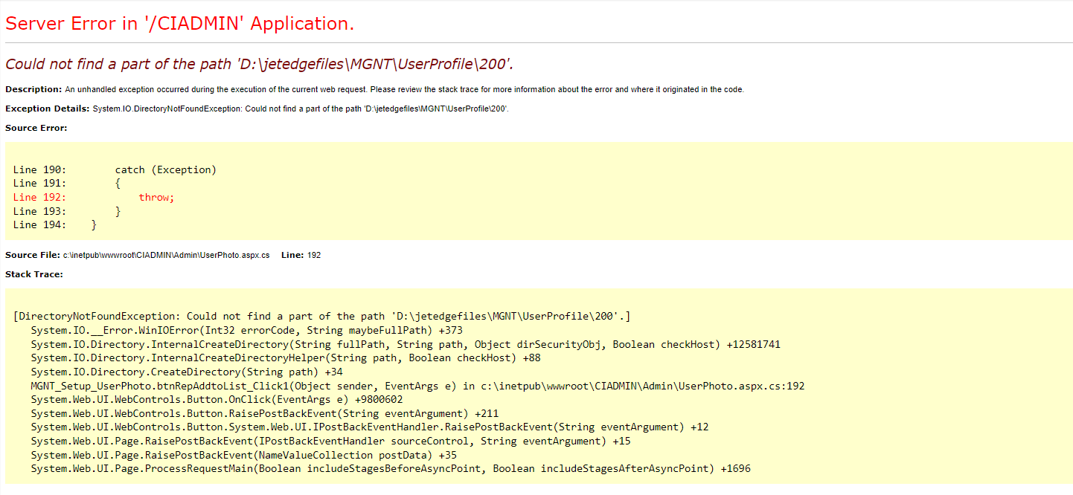
2. Admin-Create user-Add/Edit-After enter valid details and click clear button, country and state value is not gettting cleared. It need to show “Please select”.

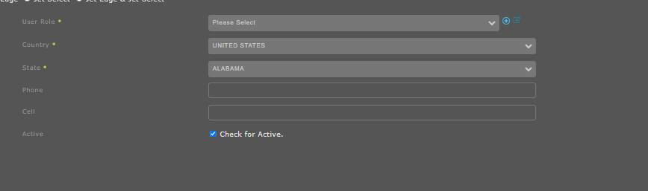

1. Admin-Audit-Run Report-Heading displayed is wrong details.

